

**SCHOOL OF ELECTRICAL AND ELECTRONICS ENGINEERING**

INTERNSHIP REPORT

ON

# TRANSFORMER S K HIGH VOLTAGE EQUIPMENTS, #10&11, S. L.V INDUSTRIAL ESTATE, 8TH MAIN, 10TH CROSS, ANDRAHALLI MAIN ROAD, BANGALORE-560058

Submitted in fulfillment of the requirements for the award of the degree of

**BACHELOR OF TECHNOLOGY**

**IN**

**ELECTRICAL AND ELECTRONICS ENGINEERING**

**SUBMITTED BY**

**MONIKA G S**

**R22EM048**

**5th SEM**

**2024**

# REVA UNIVERSITY

RUKMINI KNOWLEDGE PARK, KATTIGENAHALLI, YELAHANKA

BANGALORE 560064



**SCHOOL OF ELECTRICAL AND ELECTRONIC ENGINEERING**

# CERTIFICATE

This is to certify that the “**INTERNSHIP REPORT”** submitted by **MONIKA G S(R22EM048)** is work done by her and submitted during 2023 – 2024 academic year, in partial fulfillment of the requirements for the academics of **BACHELOR OF TECHNOLOGY** in **ELECTRICAL AND ELECTRONICS ENGINEERING** at **S.K. HIGH VOLTAGE EQUIPMENTS, #10&11, S.L.V Industrial Estate, 8th Main, 10th Cross, Andrahalli Main Road, Bangalore – 560058.**

|  |  |
| --- | --- |
|  |  |
| **Company Supervisor:**  **Mr. Kashinath D.M** | **Dr. Raghu C N**  **Director, School of EEE** |
| **Internship Coordinator: Prof. Jaya Krishna** | **Placement Coordinator: Dr. Adithya Balaji** |
| **Examiners:** |  |

## 

## ACKNOWLEDGMENT

The joy and satisfaction that accompany the ongoing process of any task would be incomplete without thanking those who made it possible. I consider myself proud to be a part of REVA University, the institution which moulded me in all my endeavours.

University, for providing state of I would like to thank Dr. P Shyama Raju, Chancellor, REVA University, Dr. N Ramesh, Vice Chancellor, REVA University, Dr. K S Narayana Swami, Registrar, REVA University, Dr. Raghu C N, Director, School of Electrical and Electronics Engineering, REVA art facilities.

Next I express my profound gratitude to the Placement and Training Vertical Head Dr. Adithya Balaji and Internship coordinator Prof. Jaya Krishana, School of EEE who have given valuable suggestions and guidance throughout the program.

I express my gratitude to company supervisor Mr. Kashinath D.M, S.K.HIGH VOLTAGE EQUIPMENTS for helping me and supporting me throughout our internship period.

Finally, I would like to express my sincere gratitude to all the teachers for helping me and supporting me throughout the course of engineering and during the internship period.

MONIKA G S

(R22EM048)

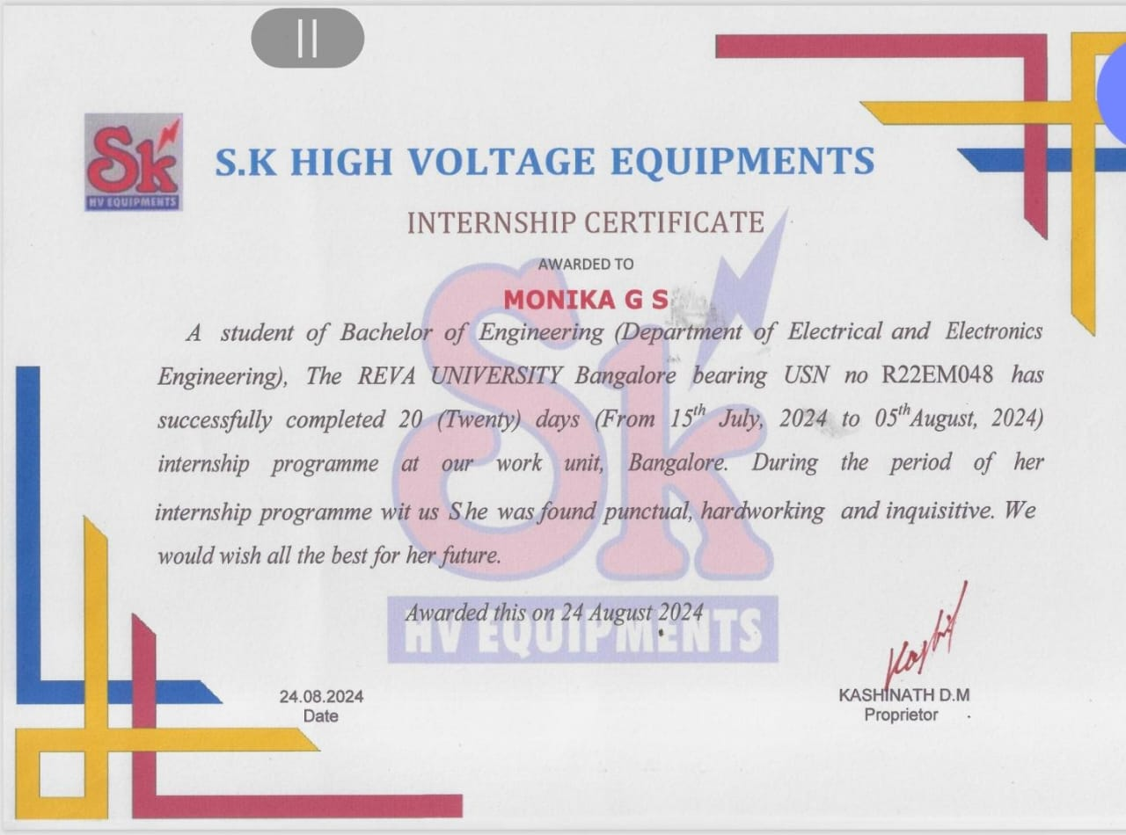

**ABSTRACT**

This report summarizes my internship experience at S.K. HIGH VOLTAGE EQUIPMENTS, a leading manufacturer of power transformers. During my [X]-week internship, I worked closely with the engineering and production teams to gain hands-on experience in the development, and testing of transformers. My responsibilities included assisting in the design and simulation of transformer models, participating in factory tours and production meetings, and contributing to the development of a new transformer prototype. Through this internship, I gained valuable industry insights and practical skills in transformer, manufacturing, and testing. I also had the opportunity to apply theoretical concepts learned in the classroom to real-world problems, enhancing my understanding of transformer technology and its applications. This report provides an overview of my internship experience, including my accomplishments, challenges, and recommendations for future improvements.

**INDEX**

|  |  |  |
| --- | --- | --- |
| **Sl. No** | **Content** | **Page No** |
| 1 | Certificate | I |
| 3 | Acknowledgement | II |
| 4 | Abstract | III |
| 5 | Index | IV |
| 6 | Learning Objectives/Internship Objectives | 6 |
| 7 | Introduction  Chapter-1  1.1 Company profile  1.2 Company offering products  1.3 Core | 7-9 |

|  |  |  |
| --- | --- | --- |
| 8 | Chapter-2  2.1 Transformer  2.2 Step-up transformer  2.3 Step-down transformer  2.4 Isolation transformer  2.5 Auto transformer | 10-16 |

|  |  |  |
| --- | --- | --- |
| 9 | Chapter-3  Winding  3.1 Transformer specification  3.2 250 KVA Transformer specification  3.3 Requirement of specification  3.4 Type of core construction  3.5 Basic materials for the winding  3.6 Types of winding  3.7 Layer winding  3.8 Coil winding | 17-21 |

|  |  |  |
| --- | --- | --- |
| 10 | Chapter-4  4.1 Current Transformer  4.2 Potential Transformer | 22-23 |
| 11 | Chapter-5  5.1 Testing of 250 KVA and 500 KVA Transformer  5.2 250 KVA Transformer testing  5.3 500 KVA Transformer testing | 24-26 |

|  |  |  |
| --- | --- | --- |
| 12 | Conclusion | 27 |
| 13 | Reference | 28 |

**Learning Objectives/Internship Objectives**

* Skill Development: Gain practical, hands-on experience in a specific industry or field, enhancing both technical and soft skills.

* career Exploration: Understand the day-to-day operations and dynamics of a particular industry, helping to determine if it's the right career path.

* Networking: Build professional relationships with colleagues, mentors, and industry professionals to expand your network and future opportunities.

* Real-world Application of Academic Knowledge: Apply theoretical knowledge from academic coursework to real-world tasks and projects.

* Professionalism: Develop workplace habits, time management, communication skills, and adaptability in a professional environment.

* Goal Setting and Achievement: Set specific goals at the beginning of the internship and track progress throughout the experience.

* Confidence Building: Increase self-confidence by overcoming challenges and accomplishing meaningful work.

* Feedback and Improvement: Receive constructive feedback from supervisors and peers to identify areas for improvement and professional growth.

### INTRODUCTION CHAPTER-1

**1.1 Company Profile**

S.K. High Voltage Equipments is a leading manufacturer and supplier of high-voltage electrical equipment, located in Bangalore, India. With years of experience in the industry, they specialize in designing and developing innovative solutions for various high-voltage applications. Their product range includes power transformers, switchgears, control panels, and more. S.K. High Voltage Equipments is committed to delivering top-quality products and services, catering to the needs of diverse industries such as power generation, transmission, and distribution. Their team of experts ensures that all products meet international standards, providing reliable and efficient solutions for customers."

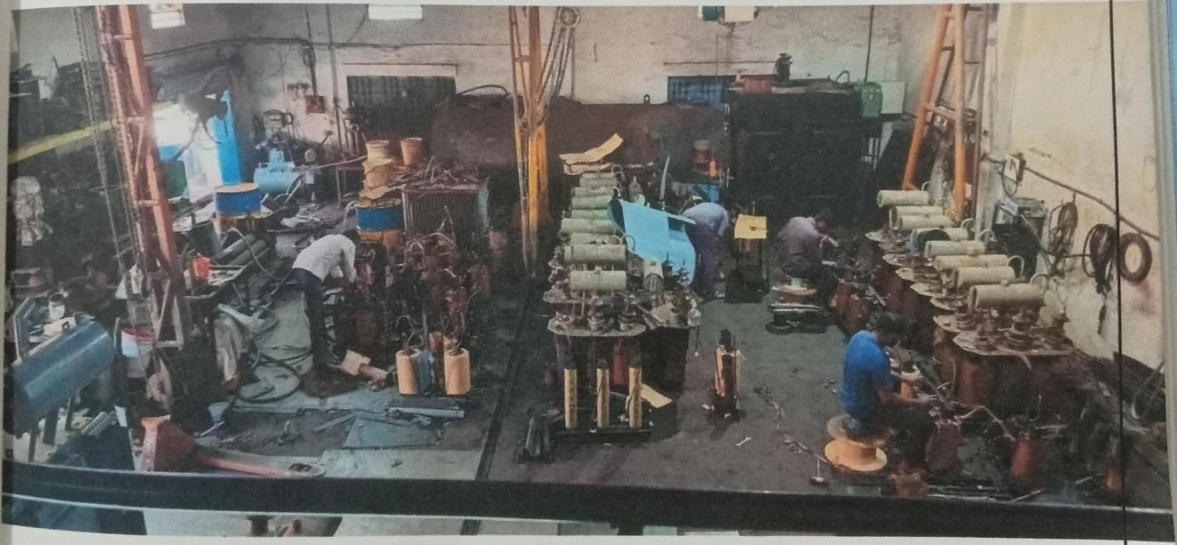

**Fig 1.1 Picture of our company**

This is our company picture which we work they under take orders from the private company and government companies like BESCOM and supply the transformer about four to five areas in hegganahalli near peenya second stage they also under take the repair of a transformer that are occurring faults during the supply and they also under take the work of rewinding of a transformer

#### 1.2 S K High Voltage Equipments offers a wide range of products, including

* **High Voltage Generating Equipments:** High Voltage AC Tester, High Voltage DC Tester
* **High Voltage Testing Equipments**: High Voltage Testers, Oil Test Kits, Relay Test Kits

#### • Distribution Transformer Testing Equipments: Lt Distribution Panels, Ht Panel • High Voltage Transformers: Oil Cooled Transformer

* **Measuring Equipments**: Winding Resistance Meter, Turn Ratio Meter, Electronic Universal Testing Machine
* **Other Products**: Armature Winding Machine, Oil Filtration Machine, Current Transformer Test Set, Rod Gap Apparatus, Sphere Gap Assembly

**1.3 Core**

A transformer core is the central part of a transformer, responsible for providing a magnetic path for the transformer's windings. Its main functions are:

* Magnetic Conduction: Directs the magnetic flux generated by the primary winding to the secondary winding.
* Flux Concentration: Concentrates the magnetic flux to increase the transformer's efficiency.
* Reducing Eddy Currents: Laminated cores reduce eddy currents, minimizing energy losses.

**Types of transformer cores:**

1. Solid Core: A single piece of magnetic material.
2. Laminated Core: Thin layers of magnetic material, insulated from each other.
3. Toroidal Core: Ring-shaped core, often used in high-frequency transformers.
4. Ferrite Core: Made from ferrite materials, used in high-frequency transformers.
5. Amorphous Core: Made from amorphous metals, offering high efficiency and low losses.

**Core materials:**

1. Silicon Steel: Commonly used, offers good magnetic properties.
2. Ferrite: Used in high-frequency applications, has high resistivity.
3. Nickel-Iron Alloys: Offers high permeability and low losses.
4. Amorphous Metals: Used in high-efficiency transformers.

We also learnt that the cutting of core in the thickness of 0.2 thickness for the transformers the thickness will not be the same for all the transformers it depends upon the transformer capacity KVA.

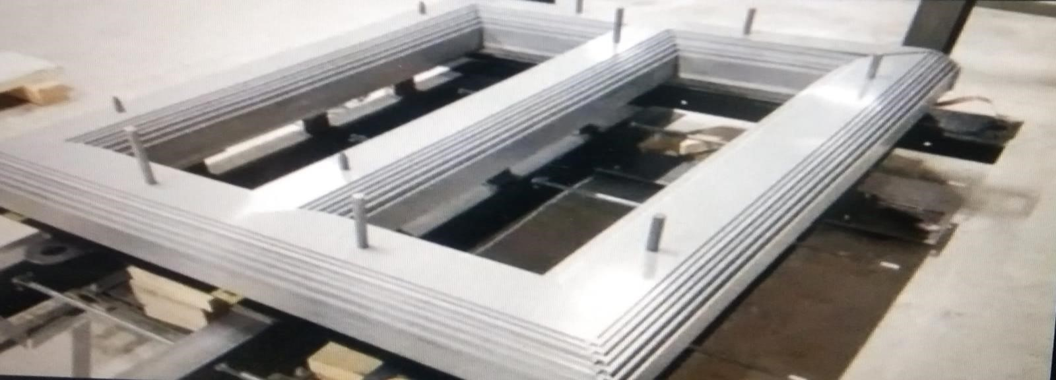

**Fig 1.2 Alignment of core**

After the cutting of the sheets they should be arranged in the proper way in the transformer if any mistakes happen while the alignment of a core there is chances of short circuit and no supply to the winding breaking of flux in the transformer.

### CHAPTER-2

#### 2.1 Transformer

#### Fig 2.1 Transformer

#### 

A transformer is an electrical device that transfers electrical energy between two or more circuits through electromagnetic induction. It's a crucial component in electrical power systems, enabling the efficient transmission and distribution of electricity.

**Types:**

1. Step-up transformer: Increases voltage
2. Step-down transformer: Decreases voltage
3. Isolation transformer: Provides electrical isolation
4. Auto-transformer: Single coil with multiple taps

**2.2 Step-up transformer:**

A step-up transformer is a type of transformer that increases the voltage of an alternating current (AC) electrical signal. It's commonly used in power transmission and distribution systems to boost the voltage of generated power to high levels, making it more efficient to transmit over long distances.

**Key characteristics:**

1. Increases voltage from primary to secondary winding
2. Decreases current from primary to secondary winding
3. Has more turns on the secondary winding than the primary winding
4. Used for power transmission, distribution, and electrical isolation

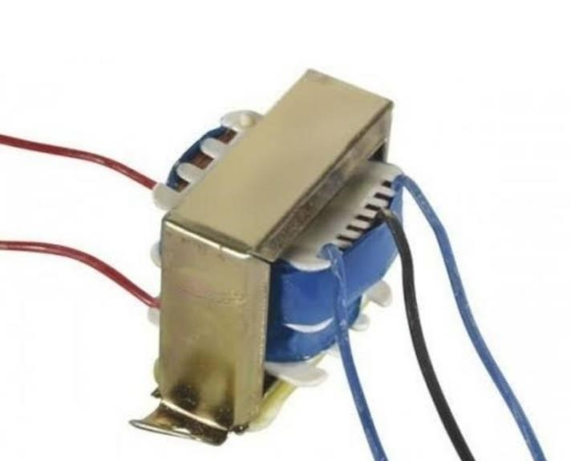

#### Fig 2.2 Step up transformer

**Applications:**

1. Power plants: Increases generated voltage for transmission
2. Transmission substations: Boosts voltage for long-distance transmission
3. Distribution substations: Steps up voltage for local distribution
4. Industrial power systems: Provides high voltage for industrial applications

**Advantages:**

1. Efficient transmission over long distances
2. Improved system reliability

**Disadvantages:**

1. Higher cost compared to step-down transformers
2. Larger size and weight due to more turns on the secondary winding
3. Increased risk of electrical breakdown at high voltages

Step-up transformers are crucial in electrical power systems, enabling the efficient transmission of power over long distances. They're used in various applications, from power plants to industrial power systems, to ensure reliable and efficient power supply.

**2.3 Step-down transformer:**

A step-down transformer is a type of transformer that decreases the voltage of an alternating current (AC) electrical signal. It's commonly used in electrical power distribution systems to reduce the high voltage of transmitted power to a lower voltage suitable for consumer use.

**Key characteristics:**

1. Decreases voltage from primary to secondary winding
2. Increases current from primary to secondary winding
3. Has fewer turns on the secondary winding than the primary winding
4. Used for power distribution, electrical isolation, and voltage regulation

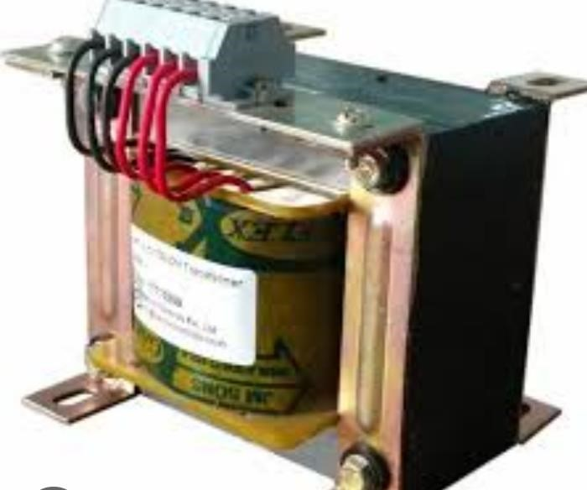

**Fig 2.3 5KVA Step down transformer**

**Applications:**

1. Distribution substations: Steps down voltage for local distribution
2. Commercial and industrial power systems: Provides lower voltage for local distribution

**Advantages:**

1. Safe voltage levels for consumer use
2. Efficient energy transfer
3. Compact design and lower cost 4. Wide range of voltage ratings available **Disadvantages:**

1. Energy losses during transformation
2. Limited capacity for

**2.4 Isolation transformer:**

An isolation transformer is a type of transformer designed to provide electrical isolation between the input and output circuits. It's used to:

1. Isolate two circuits electrically
2. Provide a safe voltage level
3. Reduce electrical noise and interference
4. Protect against electrical shocks

**Key characteristics:**

1. 1:1 ratio (primary and secondary windings have the same number of turns)
2. No electrical connection between primary and secondary windings
3. Galvanic isolation (no direct electrical path)
4. Shields or screens to reduce electromagnetic interference

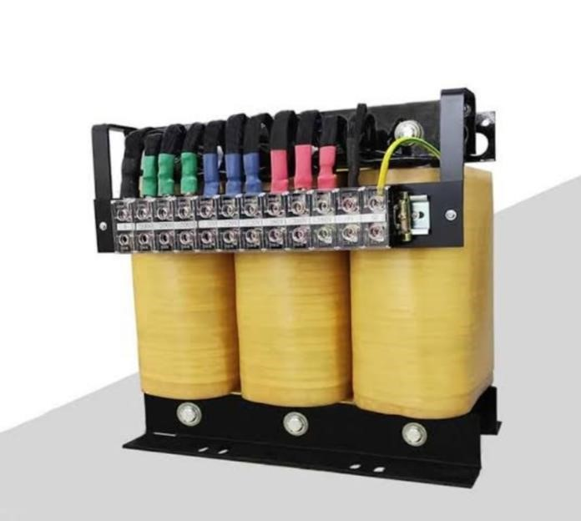

**Fig 2.4 Isolation transformer**

**Applications:**

1. Medical equipment (patient safety)
2. Laboratory equipment (measurement accuracy)
3. Audio equipment (noise reduction)
4. Telecommunication systems (signal isolation)
5. Industrial control systems (safety and reliability)

**Benefits:**

1. Electrical safety
2. Reduced noise and interference
3. Improved signal quality
4. Protection against electrical shocks
5. Compliance with safety standards (e.g., medical equipment)

**Types of isolation transformers:**

1. Air-core isolation transformers
2. Iron-core isolation transformers
3. Toroidal isolation transformers
4. High-frequency isolation transformers

**2.5 Auto transformer:**

An auto-transformer is a type of transformer that has only one winding, which serves as both the primary and secondary winding. It's a single coil with multiple taps, allowing for multiple voltage levels.

**Key characteristics:**

1. Single winding (primary and secondary combined)
2. Multiple taps for different voltage levels
3. No electrical isolation between primary and secondary
4. Compact design and lower cost

**Applications:**

1. Voltage regulation
2. Power transmission and distribution
3. Industrial power systems
4. Audio equipment(e.g.amplifiers)
5. Electronic devices (e.g., power supplies)

**Benefits:**

1. Compact design and lower cost
2. Higher efficiency (less energy loss)
3. Simple construction and maintenance
4. Wide range of voltage ratios available

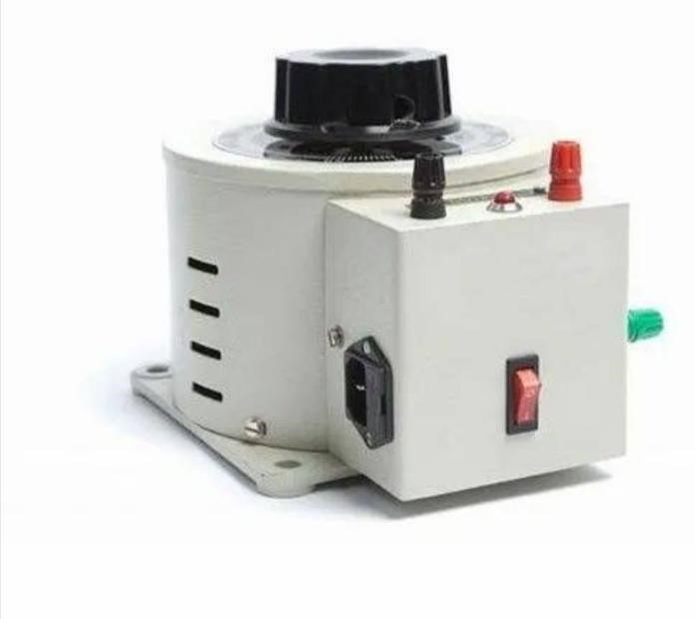

**Fig 2.5 Auto transformer**

**Types of auto-transformers:**

1. Step-up auto-transformer
2. Step-down auto-transformer
3. Variable auto-transformer (e.g., Variac)

**Limitations:**

1. No electrical isolation between primary and secondary
2. Limited voltage range
3. Not suitable for high-power applications

Auto-transformers are commonly used in applications where voltage regulation and efficiency are important, but electrical isolation is not required. They're a cost-effective and compact solution for many power systems and electronic devices.

**Components:**

1. Primary winding (input)
2. Secondary winding (output)
3. Core (magnetic material)
4. Insulation

**Principle:**

1. Electromagnetic induction
2. Mutual inductance between primary and secondary windings

**Functions:**

1. Voltage transformation
2. Current transformation
3. Impedance matching
4. Electrical isolation

**Applications:**

1. Power generation and distribution
2. Industrial power systems
3. Electronic devices (e.g., power supplies)
4. Audio equipment (e.g.amplifiers)

**Characteristics:**

1. Efficiency (typically 95-99%)
2. Voltage ratio
3. Current ratio
4. Power rating
5. Frequency response

#### CHAPTER - 3

#### WINDING

**3.1 Transformer specification**

First of the company we discussed about the transformer basic part and their functions and that's the basic that we learnt in the company. According to the syllabus that we have to work in a two different field in a electric field the company that which we joint is name as [S K High voltage equipments]. This company Transformers to the city and supply them to the BESCOM. Here we have to choose two different field to work in the company that is winding and testing of the transformer that is related to the electric field and rest of work is related to the mechanical. First field is winding of it transformer.

**3.2 250 KVA Transformer**

**Specification of Transformer**

1. Type: out door, oil cooled
2. KVA rating: 250
3. Rated voltage H.V.(Volts)L.V.(Volts);11000 and 433
4. Rated current H.V.(Amp) ;13.12 L.V.(Amp) :333.34
5. Number of phases: 3
6. Connection H.V./ L.V: Delta/star
7. Frequency (Hz) :50
8. Type of cooling: ONAN
9. Temperature rise of oil: 50 c
10. Percentage Impedance: 4.5%
11. Primary winding conductor: copper or Aluminium
12. Second winding conductor: copper or Aluminium
13. Quantity of oil (Litre):330
14. Hight and width: 580 and 158
15. Weight of winding: 75(Kg)
16. Total weight (Kg): 1,288 Kg

250 KV 3 phase transformer consists of one primary and secondary winding, each for voltage transformation. These two coils are highly inductive that are wound on a steel or iron core.The winding attached to the AC supply is the primary or first winding, while the other is the secondary winding output. 250 KV[2500]/66KV/11KV/433V is also used for a step down and up transformer. Oil cooled type transformer that are mainly placed in outdoors in the substations to step down or up to the voltage.

**3.3 We learnt that the Requirements of specification**

3.3 We learnt that the Requirements of specifications

* Mandatory
* KVA rating
* Voltage ratio
* System earthing
* The number of phase and frequency
* Connection and vector group
* Tapping and tapping switch
* Service condition type of installation
* Cooling
* Winding materials
* Altitude of installation
* Type of mounting

**3.4 Type of core construction**

* The handling factor while calculating a noload loss
* Strong loss in a percentage of a FR loss
* Shape of tank body
* Sheet thickness of tank including top and bottom
* Slope on tank cover if any
* Nonmagnetic plate
* Provision of conservator its size
* Noise level
* External and internal clearance

In our company we got a big order to build a 30 no’s 250 kVA transformer so that our owner explain the specification of a transformer and the 250 KVA is a 3phase transformer 2500V capacity and the output is 11 KV/415V.It is a stable transformer it steps downs the high voltage AC power to lower voltage level without any change in current and frequency. The maximum 100% load for 250 kVA transformer is 2930 watts and 50% load for 250 KVA transformer is 980 watts.

.

**3.5 Basic materials for the windings of the transformers we used**

* Annealing of wires and strips
* Annealing of copper
* Annealing of Aluminium
* Insulating papers
* Papers for the covering conductor
* Picture of 250 kVA transformer
* Some pictures of our team mates works on the winding of the transformer

**3.6 Types of windings that we have done in the company**

* Layer winding
* Coil winding

**3.7 Layer winding**

Layer windings are done in a transformer in high voltages. Layer windings are actually placed in the core inside the transformer for the reason to fill the oil into the transformer to order to maintain the heat of the transformer due to overheat of transformer.

##### Fig 3.1 Layer winding

**Key characteristics:**

1. Wire is wound in layers, with insulation between each layer
2. Layers are typically wound in a specific pattern (e.g., clockwise or counterclockwise)
3. Each layer is connected to the next to form the complete coil
4. Used for transformers, inductors, and other magnetic components

**Advantages:**

1. Improved thermal management (reduced heat buildup)
2. Increased electrical insulation (reduced risk of short circuits)
3. Better mechanical stability (reduced vibration and stress)
4. Easier manufacturing and assembly

**Types of layer winding:**

1. Concentric layer winding (layers wound concentrically)
2. Radial layer winding (layers wound radially)
3. Helical layer winding (layers wound helically)

**Applications:**

1. Power transformers
2. Audio transformers
3. Inductors
4. Magnetic components (e.g., choke coils, filter coils)

**3.8 Coil winding**

Coil windings are done in the transformer in a low voltages coil windings are actually placed in the course inside the transformer. This windings are made in a shape of the small coil type this windings are placed one by one inside the core of the transformer they are actually used in a dry transformer where the oil is not a stored instead the transformer get cooled by the air.

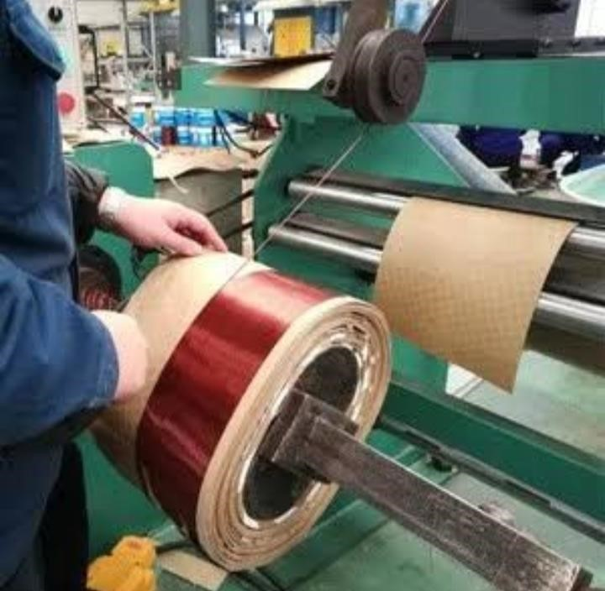

**Fig 3.2 Coil winding**

**Types of coil winding:**

1. Manual winding: Done by hand, often for small quantities or custom coils.
2. Machine winding: Automated process using machines, suitable for large quantities.
3. Bobbin winding: Wire is wound onto a bobbin, used for transformers and inductors.
4. Toroidal winding: Wire is wound onto a toroidal (doughnut-shaped) core.
5. Helical winding: Wire is wound in a helical (spiral) shape.

**Coil winding techniques:**

1. Clockwise and counterclockwise winding
2. Layer winding (as we discussed earlier)
3. Concentric winding
4. Sectional winding
5. Progressive winding

**Coil winding materials:**

1. Copper wire (most common)
2. Aluminum wire
3. Insulated wire (e.g., enamel, varnish, or tape)
4. Magnetic cores (e.g., ferrite, iron, or nickel)

**Applications:**

1. Transformers
2. Inductors
3. Motors

**Coil winding considerations:**

1. Wire size and insulation
2. Core material and shape
3. Winding density and pattern
4. Electrical and thermal performance
5. Mechanical stability and durability

Coil winding is a critical process in the manufacture of many electrical components, requiring attention to detail and precision to ensure optimal performance.

CHAPTER-4

**4.1 Current Transformer (CT):**

A Current Transformer (CT) is an electrical device that measures alternating current (AC) and produces a proportional reduced current, allowing for:

1. Accurate current measurement
2. Isolation of measurement circuits from high currents
3. Protection of equipment from excessive currents

Fig 4.1 Current Transformer

**Key characteristics:**

* Primary winding connected in series with the load
* Secondary winding provides a scaled-down current output
* Turns ratio determines the current transformation ratio
* Used for metering, protection, and control applications

**4.2 Potential Transformer (PT):**

A PT (Potential Transformer) is a type of transformer used in electrical power systems to measure high voltages. It's a step-down transformer that reduces high voltages to lower voltages, allowing for safe and accurate measurement of voltage levels.

**Here's how it works:**

1. The primary winding is connected to the high-voltage system (e.g., transmission lines, substations).
2. The secondary winding is connected to the measuring device or relay

##### 

##### 

##### Fig 4.2 Potential transformer

**PT transformers are used for:**

1. Voltage measurement
2. Power system monitoring
3. Protection relaying
4. Control systems
5. Metering and monitoring

CHAPTER 5

##### 5.1 Testing of 250 KVA and 500 KVA Transformer

Transformers place a vital role in the electrical power industry by the facilitating the efficient transmission

and distributing of the electricity. To ensure their safe and reliable operation, testing procedure necessary these report presents the overview of testing procedures carried out on a 250 KVA and 500 KVA transformers.

The tests conducted help in the evaluating the performance, insulation integrity and overall reliability of these

transformer.

Fig 5.1 Transformer Test

**5.2 250 KVA Transformer Testing**

##### Test 1: Turns Ratio Test

The turns ratio test measures the voltage ratio between the primary and secondary windings of the transformer.

By comparing the measured turns ratio with the rated turns ratio, it is possible to determine if there are any faults in the transformer windings or connections.

##### Test 2: Insulation Resistance Test

The insulation resistance test Axis the insulation integrity of the transformer by applying the high DC voltage

between the windings under Transformers core the resistance of the insulation is measured a higher resistance

value indicate the better insulation quality ensuring the safety and reliability after transformer

Fig 5.2 250 KVA Transformer

Test 3: Load Loss Test

The load loss test determines the transformers losses under normal operating conditions. By applying a specific load other transformer and measuring the power consumed, the load loss is calculated. These test ends in a evaluating the efficiency of the transformer and its ability to handle the expected load.

##### Test 4: Impedance Test

The impedance test measures the voltage drop across the transformer when subjected to a specific load

It helps in determining the internal impedance of the transformer which is a crucial for evaluating it voltage regulation capability and overall stability

##### Test 5: Partial Discharge Test

The partial discharge test detects and evaluates partial discharges occurring within the transformer insulation. Partial discharges, if left undetected, can lead to insulation breakdown and eventual failure. This test is a performed using sensitive sensors to capture the magnitude and occurrence of a partial discharge, helping to assess the overall insulation condition.

##### 5.3 500KV Transformer Testing

Fig 5.3 500 KVA transformer testing

Test 1: Temperature Rise Test

The temperature rice test determines the ability of the Transformer to dissipate heat generated during a normal operation. The transformer is loaded to its rated capacity while monitoring the temperature rise in a various part of the unit. This test ensures that the transformer can operate within the same temperature limits, preventing excessive heat damage.

##### Test 2: Short-Circuit Test

The short-circuit test is conducted to determine the transformer’s ability to withstand short-circuit currents. A high current is injected into the secondary winding for a short duration, simulating a fault condition. This test help’s in assessing the transformers mechanical strength, protection mechanisms, and overall performance during the short-circuit event.

##### Test 3: Sound Level Test

The sound level test measures the acoustic noise produced by the transformer during operation. Excessive noise can indicate mechanical issues, loose components, or improper core assembly. These test helps in a identifying any potential problems that may affect the transformers performance are causes discomfort in its surroundings

#### CONCLUSION

In conclusion, transformers are the backbone of modern electrical power systems, playing a vital role in transmitting and distributing electrical energy efficiently and safely. The winding, core, and other components of a transformer work in harmony to enable the reliable operation of power grids, industries, and households.

The design and development of transformers involve a deep understanding of electromagnetic principles, materials science, and electrical engineering. The winding, which carries the electrical current, and the core, which provides the magnetic path, are critical components that determine the transformer's performance, efficiency, and durability.

Testing is an essential aspect of transformer development, ensuring that these complex devices meet industry standards, perform optimally, and operate reliably. Routine tests, type tests, and specialized tests help detect potential faults, verify performance, and guarantee compliance with safety and efficiency regulations.

As the demand for electrical energy continues to grow, the importance of transformers and their components will only increase. Advancements in materials, design, and testing will play a crucial role in developing more efficient, sustainable, and resilient transformers. By prioritizing innovation and quality in transformer development, we can ensure a stable, secure, and efficient electrical supply for generations to come.

This expanded conclusion provides a more detailed summary of the importance of transformers, their components, and testing, as well as the future outlook for transformer development.

REFERENCE

* [**https://www.skhvtge.c**](https://www.skhvtge.c)[**om**](https://www.ggtronics.com/)
* [**https://www.skhvtge.com/engineeri**](https://www.skhvtge.com/engineeri)[**ng-services.html**](https://www.ggtronics.com/engineering-services.html)
* [**https://in.linkedin.com/company**](https://in.linkedin.com/company/)[**/**](https://in.linkedin.com/company/g-g-tronics-india-pvt-ltd)**s**[**-**](https://in.linkedin.com/company/g-g-tronics-india-pvt-ltd)**k-h-vtge**[**-india-pvt-ltd**](https://in.linkedin.com/company/g-g-tronics-india-pvt-ltd)
* **https://www.indiamart.com/skhvtge**[**-indiapvtltd/aboutus.html**](https://www.indiamart.com/ggtronics-india-pvt-ltd/aboutus.html)

#### 

#### 